Text to TEXTRAUM about Education to lead
Bibliodrama online
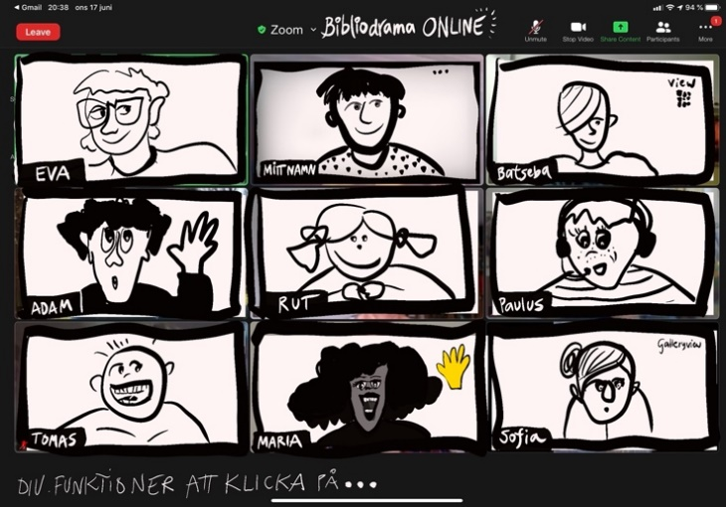
Background
The interest in leading Bibliodrama online rose during the pandemic. The Bibliodrama society in Sweden wanted to create a pilot education during spring 2021 and gave Lotta Geisler and Anna Gradin the mission to work upon such a course. Contacts were made with cooperating partners as: Umeå folkhögskola, Studieförbundet Bilda and Sensus Studieförbund. (A folkhighschool and two Study associations).
Lotta and Anna gave an invitation to a meeting online on the 5th of December 2020, to measure the interest and needs for such a kind of online education. Many good ideas came up. The aim was to invite people to an education that could give tools and experiences for being able to lead a shorter Bibliodrama online. The goal then became to implement an intensive education in three parts during eleven weeks. The first part included a six-week folkhighschool course of 25 percent, with literature studies and own experiences of Bibliodrama online, led by the course leaders, as well as preparations for individual internship. The content of the second part was about offering and leading a Bibliodrama online together with a co-leader (as a technical support from the course) in cooperation with one of the two study associations, “Sensus” or “Bilda” (see above). In conclusion there was three weeks folkhighschool course 25 percent, for exchange of experiences, reflection, and evaluation.

The cooperation together from the Bibliodrama society in Sweden with the folkhighschool and study associations was important to clarify and least to activate their possible support, one of the intentions of the education. These cooperation partners have been and are important for futural Bibliodrama associations and the participants had to make their own contact with the local agencies of these study associations in planning their internship content.

The target group for this education was Bibliodrama leaders who already had been examined in the Bibliodrama ground course and tried internet/online for learning already or corresponding experiences. Knowledge of Bibliodrama was necessary for this kind of education. The invitation was sent out personally to all of those who had participated in one of the six Bibliodrama basic courses that had been carried out since 2005 in Sweden as well as via the newsletter from the Swedish Bibliodrama society and the homepage.
Summary of the whole course
Suggestions on agreements and introductions to Zoom were sent out just before the start of the course. The Implementation happened between the 8th of February and the 23^{d} of April 2021 with ten participants. All of them trained in the Bibliodrama basic Course and some of them also in the qualification course. There was also a participant from Finland, able to talk Swedish.
Every Monday evening there was an online meeting on Zoom and the participants had tasks to do between the meetings and share with the education group. The total course time per week was about ten hours. The weekly meetings contained follow ups and processing the homework; introduction of the internship and to be given experiences of Bibliodrama online as a participant (led by the course leaders). Different kinds of exercises were tried. The participants attended without any absence! Everyone implemented their internships, Bibliodramas with participants from their own contact network or through the advertising of the local study association. Great emphasis was placed on learning together and learning from each other and a lot of time was given for reflection. The participants had to take responsibility for their own learning and find their own ways to lead online. Training in the digital technology had to take up a lot of space because the connection between methodology and technology was important.

About fifty people around Sweden and Finland got to try Bibliodrama through these Bibliodrama internships, where some had tried Bibliodrama before and some hadn´t. Several of these participants wanted a continuation.
An evaluation was made by the course participants and a follow-up meeting was held later in the spring to listen to what happened and capture future needs.
The start of the contact with the participants
A proposal on approach and how the implementation was intended to happen was sent to participants beforehand to read, ponder, and respond to before the start. It was important to emphasize the nature of the education with process, joint learning and co-creation, responsibility for one´s learning process and interest in each other´s processes.
Agreement
- The course takes place in the arena of education, with Umeå folk high school and the Sensus study association and the Bilda study association
- Bibliodrama is public education by its very nature and the course takes place in a process with the experiment as an approach. Bibliodrama Online takes place in the same spirit.
- The course leaders lead the process, but everyone is a co-creator. It becomes what we make it…! You are important and contribute to the whole.
- Everyone takes responsibility for their own learning, dares to ask questions, and provide input. It is okay to say PASS in an exercise!
- We are different and will remain so. You get to be who you are. The differences in the group are an asset! We don´t need to compare ourselves to each other.
- We are interested in each other´s processes and we give ourselves and each other space. We train our ability to pay attention and to have an inner openness in our work. We read each other´s post and share from ourselves, as if we were sitting in a circle.
- It is allowed to test and try. We give ourselves and each other that permission. In sharing reflections, ”think out loud together – try test thinking”, it doesn´t have to be fully formulated. We describe what we think and feel based on a current situation.
- What participants share of a personal nature in conversations and reflections stays within the group. We do not pass it on to others. We are of course free to share our own personal reflections with whoever we want.
Implementation
-For joint web meetings, we use Zoom, you will receive a link in an e-mail on the same day that we have the web meeting. We use e-mail to send exercises and reflections. On WhatsApp, we can create a ‘coffee room’ and the option to easily send pictures to each other.
- We meet for Zoom meetings 6-9 pm at 8th, 15th, 22^{d} of February and 1st, 8th, 15th and 22^{d} of March as well as two Tuesdays 13th and 20th of April. Be in a secluded room with no other commitments at the time of the Zoom meetings. Come prepared with current material.
- In addition to the Zoom meetings, the course leaders prepare exercises/tasks för two hours homework per week and in addition five hours of own work and reflection. Deadline for submitted material Saturday at 4 pm weekly.
- If you are prevented from participating, notify the course leaders.
- Course book “Handbook in Bibliodrama – when words meet life” is read during the course
- Take time to read what others have written for your own sake, for participation and community in the group. It is also our course literature.
- Feel free to set aside time in your calendar to do the course exercises and read other people´s reflections, it usually makes things easier.
- If there is something that is unclear during the course, big or small, ask in the group or sen an email, SMS or call the leaders.
The preparation of the course sessions/evenings
The leaders planned the first meeting and then every week before each new meeting after reading the participants ‘responses. Requests for more breaks and curiosity about different exercises were met. Questions and ambiguities could be caught quickly.
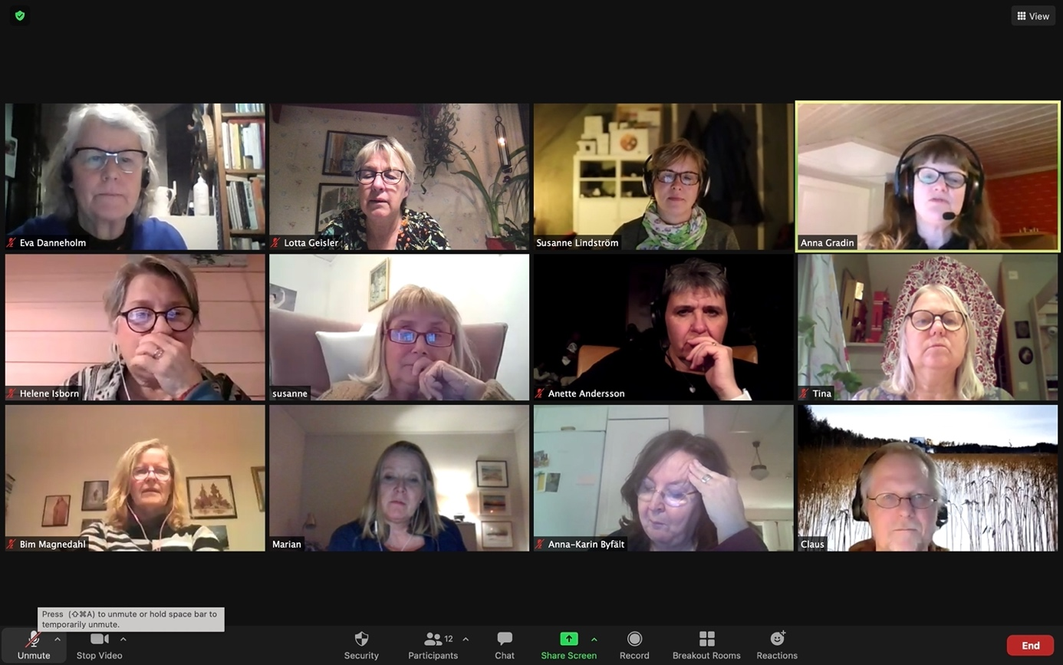
” The Journey” begins…
A detailed description of how we did it…

Course session 1
Theme: Getting started & getting to know each other
Conversation and response to agreement and the structure of the course. Conversations followed a given sequence by the participants (so called “talkinglist”).
Exercises: Share a real event when you led Bibliodrama and a fictional one. The group gets to give a thumb up to the one they think is true and a thumb down to the one they think is made up.
Bibliodrama: Warm-up with guided physical exercises (audio and possibly video closed to participants). Follow the leader or do what you need. A poem by the Swedish Nobel prizewinner Tomas Tranströmer, that was shown on the screen – were read – choose a word and connect it with Bibliodrama – draw/paint individually – share reflections in small groups (break – out rooms – we shorten it BOR) – give your picture a title - share in the whole group afterwards.
The POEM;
“From March 1979.
Weary of all who come with words, words but no language
I make my way to the snow-covered island.
The untamed has no words.
The unwritten pages spread out on every side!
I come upon the tracks of deer in the snow.
Language but no words.”

Homework to read ´Handbook for bibliodrama” about ´What is bibliodrama?´and about Anna´s first online bibliodrama in 2013.

Course session 2
Theme: The Soul of Bibliodrama – play through new technology

Conversation about the read text about online Bibliodrama in 2013 and experiences since then, fewer exercises and shorter texts that are more appropriate, but the exercises were good.
Exercise: Walk in the room – observe – let your eyes wander – pick up something that your eyes get stuck on for whatever reason – divide into pairs (BOR). Talk about what you saw that you have chosen? How does it relate to what we are doing now in the course? – coming back from BOR into the whole group and share it in the whole group with only one sentence.
For the group to listen to information in a more lively form; Lotta interview Anna: Why internship? Why these study associations? Which study association should I cooperate with? What are the frameworks for the practice/internship?

Bibliodrama: Warm-up with music, wake up the body, do what you need. A game we call” YES” which means someone suggest a movement, everybody says ”Yes” and do what is suggested, following the sequence . Shall we…? YEEESS!!! (Works just with a voice and video shut down, listening, but in the order of the prepared talking list) Keep the microphone open!
Reading the texts on the screen about Mary Luk 1 verse 26-39 and Joseph Math 1 verse 18-24, divide the group into five Josephs and five Mary´s, Adding the role name (renaming in ZOOM) to oneself – example ”Maria – Lotta”. Take this role, reading the text silently by oneself. Go into roleplay and the scene is the first meeting between Joseph and Mary after both of them have met an angel, and to explore that meeting in role (BOR, we divide them into this meeting two by two). After this they are asked to write in their Diaries still in roles. Sharing in the whole group.
Homework: To create a guardian angel from recycled materials or other and let the angel speak. Start with;” Don´t be afraid…” in front of your own internship – Bibliodrama…
Read about ´preliminary work´ in the literature plus write down a dream/vision about your own possible online Bibliodrama.

Course session 3
Theme: To convert the Bibliodrama methods into a digital platform

Sharing of the homework.
Bibliodrama: Warming-up to music, discover different environments (slippry, snowy, snowstorm, calm, water, tricky water, to row a boat…) lead by the voice of the leaders and the participants go into their own experiences offscreen.
Read the text Mark 4 verse 35-41 on the screen – leaders are reading it in a random way. Which persons are there, things, other kind of words in the text? Choose someone or something in the text, a word, and BE this word, as if…. Go into it as a role – rename - do present yourself as this (word) – talk with an “I message”, in pairs (BOR).
The whole group meet again. Rename. Make a presentation;” Who are you? Where are you?” Scene: now The wind increases a lot; Go into a play and express what is happening to you; (in the order of talking list)
Reflection in the role (in the order of talking list) “What happened to you?”
De-roling. Write about this.
Share your thoughts in the whole group again; What became important to you? How is this connected to yourself? Share a few sentences.

Homework: The literature; Sharing, text reading, creative work, reflection, closure and homework. The need of technology (ZOOM/Internet) rights now, target groups for the internship and about what each person would like to try out in their internship-Bibliodrama’s? Search for a stone.

Course session 4
Theme: A longer Bibliodrama with different methods

Introduction Reminding about the agreement
”Get to know each-other” exercise by using colored POST-IT papers on the computers camera lens.
Statements are given, and if you agree, take away your pOST-IT. The leader can also ask for comments.
- It is plus/warm degrees where I am
- It is more snow than 1 dm
- It is more snow than 50 cm
- I have enough time for everything I want to do in my leisure time
- I have participated in Bibliodrama’s online before this course
- I have been leading Bibliodrama online before this course
- Bibliodrama do challenge and inspire
Warming up: One person become A and the other B. Work in Break Out Rooms (BOR). In pairs – A is weak, and B is strong, A is big/longer and B is smaller/shorter, meet each other without words (change roles after a while) One might talk and the other one is silent. Improvise and try these different positions. Share your reflections in pairs.
Small rest/pause – Stand up and bow the back and move the arms inwards your body for a while, open and move the arms upwards and backwards – change.

Get your stone (the homework goes into the bibliodrama beneath)
Do something creative with the stone. Imagine this stone is your collected experience, with an outer surface and an inner place. Take care about this stone for a while, let it touch you, touch it, perhaps paint upon it, write about it, hold it – let the stone talk, tell, paint, write about everything it has collected (saved).
Share your experience/process with the stone together with the one who will support you in the internship (BOR) One is telling and the other one is listening, change roles.
Text: David and Goliath. Three groups are made: Philistine, Saul and David. (BOR)
Talk about what you know about this” persons/groups” and the story itself.
Share something with the whole group.
Text reading in the whole group. 1 Sam 17 verse 38 – 40. One at the time read one line on the screen, the text is shared there as a power point. Next step is to read the text on one’s own, silently. Let the eyes wander in the text as a Viagese, line after line.
The whole text on the screen is shown. “Choose a word, become this word. The leaders try to deepen the role-taking by questions like; How old are you, gender, how do you feel? what have you been through? Where are you going? why are you there? How would you present yourself to someone else? Do you have a nickname?”
Meet in your roles in pairs, (BOR) Explore what happens in this encounter? Explore it by gestures, gazes, body language without using words at first. After a while words are allowed.
The whole group meets. Leave the role at first – by rename to your own name. Move your body.
The pairs that have met, are shown to the whole group and talk about their experience so everybody can listen to that (the rest of the group is hidden). What kind of encounter was it? What happened?
Round in the whole group;” What did I hear and see? What thoughts are arising, where can I recognize myself, what touched me?
Reflection. Choose a place in your room (IRL), the leader gives the instruction, and the participants close their screen and microphones, “put your stone somewhere on your body, and have some silence while you let the stone keep on telling you what is there. Listen to it.”
Closure; A round in the whole group; What do you want to take with you from this evening session and share with us? (Talking list)
Homework: Keep on reflecting upon the text and the role taking, the telling from the stone in relation to the participant. Write about this and share.
Share also your ideas for your internship to get some responses from the group as well as reading your course mates plans.
Exercise Zoom technics at home! Prepare two refrigerator questions you find important in preparation of the internship.

Course session 5
Theme: Preparation for the internship

Check in with help of traffic signs on the screen, choosing one or more, that symbolically can tell something about your feelings about this internship planning.

Warming up of the body and to each other… Participation goes out from everyone’s circumstances. A variant of” Simon says” (”Följa John” in swedish). Camera and sound on. The leader does an exercise; Everyone imitates the movement…until next one take over, who takes over? Following the ’talking-list’.
Sharing in half-groups about where each person is in her/his process according to the internship, about ideas, wishes and fears…
Possibility to ask for responses from the group members and if, about what?

Exercise: Until now everyone has been into three roles; on from the poem, one in the text when Jesus calms the storm and one in the story of David and Goliath. Instruction; Let the roles coop with each other, play together and search for an ability, something special. Find a tool in the kitchen or a tool from a workshop storage.
Share this searching and finding in pairs (BOR) and later in the hole group.
Closure round (talking list); What do you bring with you from this session? Choose a traffic sign (shown on the screen).
Homework: Collect recycled materials or debris/scraps. Create a carrying construction.

Course session 6
Theme: Technics
Recall the homework about creating/building a carrying construction. Describe what you have done? Show it! Does this construction tell anything about you? Share this in the whole group (talking list). Use “Post-it” papers to make just one person’s telling is in focus, the focus person take his/her away during telling. Find a place for your construction close to you where you are.
Preparations for the internship: Talk in the internship-pairs about the planning of the workshop, about warming-ups, instructions, timetable, problems with internet and about own ambitions and your roles as leaders – who will do what?

Technical training in half groups arising out of needs.

Recalling the construction. Get it. Images are show on the screen as a Power-point and the participants are asked to choose one that they will add to/need to maybe, to their construction. Time for writing. Sharing in pairs (BOR). Sharing in the whole group (talking list).

Homework: Send a photo of your carrying construction. Share your planning/script of your internship-Bibliodrama with the group.

Course session 7
Theme: To be even more prepared for the internship-bibliodrama

Introduction: Find your feeling in your body right now – make a movement. Share after the talking-list in the whole group. Describe the group you will meet. What do you know about them? Draw a circle with the group on a paper. Make a movement with the drawn paper in your room. Let the paper lead you to a place in that room.

Summarize your script – make an overview. Come together with a partner (not the one you will lead your internship-Bibliodrama with), read your partners script …what do you see? Thin ice (parts) and worry clouds…read it as if it would be your own script…and think, ‘then I would expect this or that’…

Talk in the pairs about this (BOR). The sharing should be done carefully and with caution about what the reading has brought up. I-messages! The script-owner is just listening, taking notes and gives the opportunity to ask questions. Change roles.
Whole group: Get your paper and move together with it in the room and together with everyone at the same time. Share then what you bring with you from this session?
Homework: Make your internship-Bibliodrama and be the co-leaders. Read the reports from everyone sent to you by emails.

Two weeks of internship

Coursesessions 8 and 9
Theme: Exchange of the experiences of having done this internship-bibliodramas.

The half group share their experiences in one of the sessions. Both sessions the same schedule.

- The leader shares her/his reflections … thinking out load.
What have I learned during my internship online? How did it go with the thin ice? Surprises? Critical moments?
The rest of the group just listen.
- Co-host
What did I learn as a Co-host/technical support? The rest is just listening.
- Concentrated round (everybody except for the course leaders, the internship-leader and the co-host).
What became interesting when you read the report and when you have listened now? What can you recognize from your own point of view? Something concrete you found clever or a smart solution or creative.
- The leader of the internship
What became meaningful for you here and now? Something you want to comment or share? Bring attention to something you are proud and happy about?

Homework after session 9: Answer the questions from” The Refridgerator” and send it out to everyone.

Last coursweek (just digital)
Theme: Summation (Homework)

Closure of the whole course
The participants read their own reflections from the course and relate to what the others have written.
Creative work:
Collect symbols, creative expressions and play with them (Arrange them) and make an installation that expresses your learning process” to lead bibliodrama online”.
What appears? What has influenced you? What have you learned about leading bibliodrama online?
Observe your installation and write what you see.
Move around it, see it from another angle; - What do you see now? Can you smell something, tastes, sounds? Write!
Take in the installation into your body. Become it.
Follow the impulses of your body…what happens then? Write.
Give your installation a title or headline and take a photo (maybe a movie)
Share this by email to the group in a last written round.

Homework
Homework was done as emails after every Monday, between the six first sessions. The homework was to reflect and give response on each Bibliodrama/session: - What worked well and what could have been different?

The response was sent out to everyone as an answer of that weekly mail about homework. All responses were supposed to be read before next session. Responses on the last sessions continued through the whole course and was helpful for the course leaders to give the course the most expedient content. It became transparent and a good way to catch actual questions. Even the reflections from the book ‘Handbook in Bibliodrama’, how Bibliodrama’s different methods and parts can be converted online were shared. Already week two the preparations for the internship started, by dreaming and finding ideas what could be fun to try. As the course went on, the planning became more and more intense. Sometimes there were creative work as homework as a part of or as preparation for a Bibliodrama.

Reports of the internships
Everyone should write a report after the internship. The leader him/herself should write about how the implementation of the exercises went and reflect about it, the own experience of what worked, challenges, questions that were raised and do a summary of what became important. After this, the report was sent to the co-leader who could add her/his observations and reflections. This was then sent to the course leaders and the participants.

The Refrigerator
The refrigerator was a storage of important questions that were raised during the course or things that needed more time from both participants and course leaders. The content was mainly about questions related to Bibliodrama online and not everything connected to Bibliodrama as a whole. This since the participants were expected to have enough experience of Bibliodrama. It became a long list of questions and in the end, there were 26 questions that the participants could answer out of their experiences from the course and even out of what they could imagine was a solution. Even the course leaders gave their comments.

The evaluation from the participants
The education fulfilled the expectations to a large extent, and they found the wholeness/structure was very good. It was very meaningful having to implement a real Bibliodrama together in the course and especially helpful. The cooperation with the study associations worked good enough. Writing the reflections between the course sessions, said some of the participants, was demanding but they also said it was “worth its weight in gold” to gain insight into how you think yourself and was a necessary part of the learning process. It has been meaningful to take part of the other reflections. The participants have got possibilities to develop tools for leading Bibliodrama online to a very high degree. The cooperation in pairs, according to the internship, was appreciated and some of the pairs have already planned to continue and lead together after the course. The course constituted new encouragement to keep on leading Bibliodrama and bring the approach into their daily contexts. Some found the course partly too intense and most of the participants found that eleven weeks was enough, neither too short nor too long.

The evaluation of the participants, 1 – 10.
(1 mean not at all satisfied and 10 mean satisfied on a high degree.)

1.What about the course as a whole?
9,5

2. How did you find the weekly structure? Zoom-meeting in the beginning of the week, homework, and a written sharing in the end of the week?
8,7
3. How do you value the whole structure of the course; Theory – literature studies, doing own experiences being participant in Bibliodrama online, exchange of experiences and the own internship with follow-up.
9,1
4. Did the course fulfill your expectations?
9,6
5. Have you been able to develop your tools to lead Bibliodrama online?
9,5
6. How educational was it for you to carry out a practice Bibliodrama?
9,8
7. How meaningful was it to read ”Handbook in bibliodrama” and relate to Bibliodrama online? 8,5
8. How meaningful has it been to try Bibliodrama online during the course?
9,8
9. Which significance had the writing of your own reflections after every session?
8,8
10. What significance has it been to read the reflections of the course members after every session?
8,4
11. How do you value the cooperation with the study organizations as a part of the course? 6,4

The Leaders evaluation
From the moment when the idea was hatched during the board meeting autumn 2020 until the start of the education Feb 8th 2021 it went fast, including Christmastime. It was favorable to cooperate on a broad base. With many actors in an unusual cooperation, it needed some time and patience until all the parts fell into place. A patience that all participants showed, despite all administrative questions wasn´t solved when the education was advertised, there was some initial confusion in relation to the study associations about the internship course fee and how the internship should be implemented. The idea was to finance a part of the course fee by letting the internship participants pay a smaller fee. This wasn´t possible for all course participants to do.

The evaluation showed that the internship became very important on many levels as well as the exchange of experiences both before and after.
The variation of leadership became obvious and the insight that differences are enriching. It felt as if the pedagogy – to learn together and learning by doing, became the educational framework.

A big, impressive engagement from the participants was inspiring and a win to be able to meet with different backgrounds and experiences. The education came at the right time when several really had an interest to do Bibliodrama online in different ways.

Conclusion and futural effects
The aim to develop tools and experiences to lead Bibliodrama online were accommodated, with a bang! The evaluation from the participants had high results. The intention to further the cooperation with local study associations to highlight the actors of “Bildning” (public education) was implemented and this is an ongoing work where relations have been created and/or deepened.
To some of the participants it was their first contact with a study association. The future will show its effects. One participant got an offer from her study association to make Bibliodrama online five times with a group, with them as organisers. One of these Bibliodrama sessions has already happened. One of the internships pairs continued to offer Bibliodrama online together and invited participants from their local parishes.

There was an interest of a follow-up appointment upon techniques and methods and some of the participants had already planned for how they would use their newly acquired knowledge. Bibliodrama online can be advantageously alternated with physical sessions (IRL) which some of the participants already had tried.

Afterword
Many questions in bibliodrama are the same whether online or IRL; group composition, how to deal with participants unfamiliar to bibliodrama, which exercises fit to the text, expedient instructions, how to be present in an exercise etc.
Some questions are specific to working online; unsteady internet delivery, the home or office as bibliodramaroom, online security, being impossible to reach physical closeness and real face to face encounters, having a screen in between.
Further other questions about methodology are about adapting them to a digital world; images, music, roleplay, silence, textwork, responses, sharing, material…

For some people it can be an advantage that there is a screen between, like a little “shelter”. The participant can direct her/his time when it comes to individual exercises and do it in her/his own tempo. If the bibliodrama consists of repeated sessions it gives an opportunity for a deepening process in interaction with everyday life. And of course, the possibility to meet regardless where you live and over national borders without having to travel. Cheap and environmentally smart!

Important parts in the education for bibliodrama online has been; initial clearness, an extended agreement (contract) in comparison to IRL, a ‘talking-list’ where the same talking order is followed, the function to create ‘break-out rooms’ (BOR) to make it possible for smaller groups to share undisturbed, creative individual work between the sessions or as a part of a session, clear and well thought out instructions (specially with participants unfamiliar with bibliodrama), to test the technology before it is used.
It is important to believe in bibliodrama as its method and possibilities and dare to test. Only the imagination sets limits for what is possible. Start with simple things. Better an easy technique that works than an advanced technique causing troubles. To make evaluations is a constructive way to get responses and hone one's leadership and methods.

Bibliodrama is always an adventure, even online!
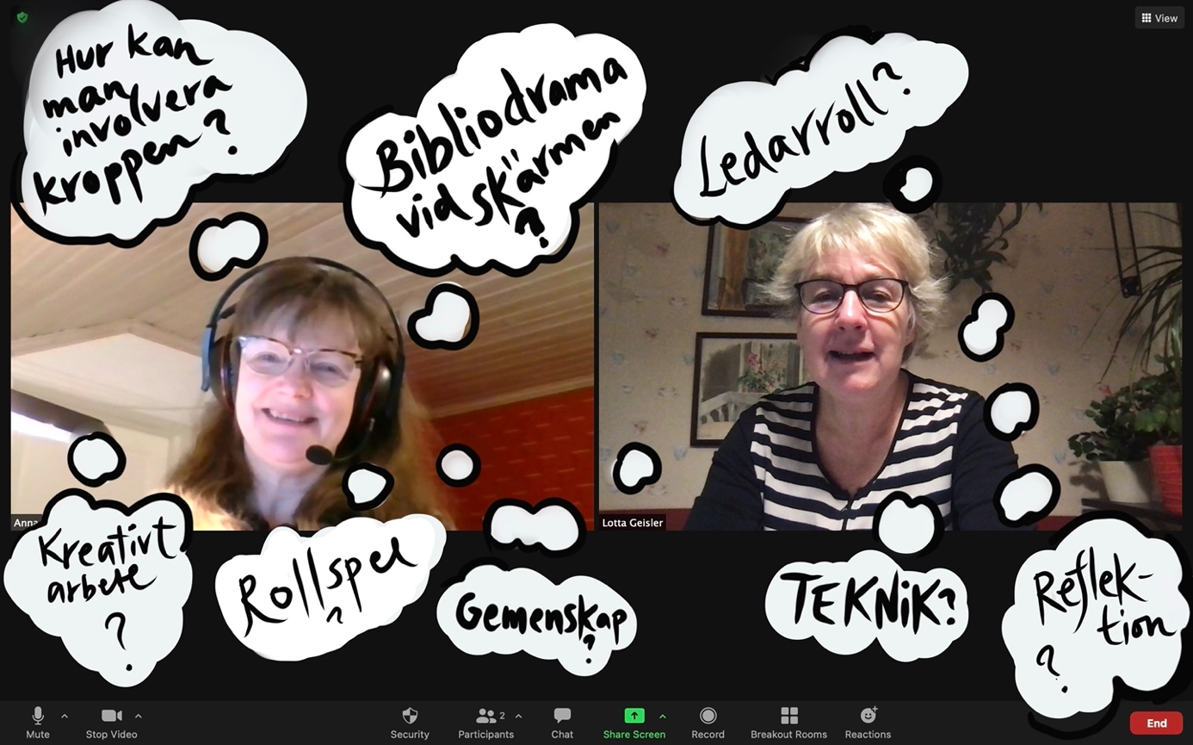Lotta Geisler lotta.geisler@gmail.com
Anna Gradin anna.gradin@umeafolkhogskola.se

